**Addendum #3**

**August 2025 Catalog Student Handbook**

**Title/Cover Page**

Page 2 is a copy of the title/cover page for the current **August 2025 Catalog Student Handbook**

Page 3 is a copy of the changed/new title/cover page for the updated **August 2025 Catalog Student Handbook**

* The verbiage, *And Aug. 2026 PT,* has been removed

I am aware that the above addendum replaces the current August 2025 Catalog Student Handbook

Title/Cover Page. I have read and understand the addendum:

Hannah E. Mullins

School of Practical Nursing

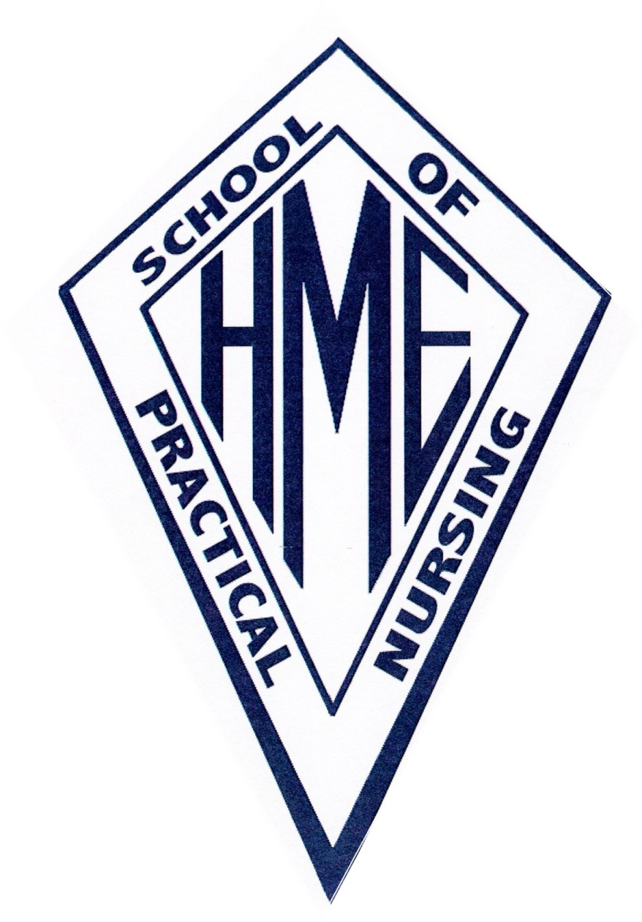

Catalog

Student Handbook

Graduating Classes of Aug. 2025 FT

And Aug. 2026 PT

Hannah E. Mullins

School of Practical Nursing



Catalog

Student Handbook

Graduating Classes of Aug. 2025 FT